Name:

Natural Selection Simulation

at PHET <http://phet.colorado.edu/simulations/sims.php?sim=Natural_Selection>

**Exploration:** Access the simulation and explore the settings. Answer the following questions:

1. 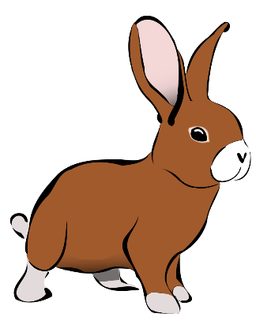What are some VARIABLES that you have control over in the simulation?

If there are wolves, who tough the food is, how much find there is.

1. What happens to the bunny population if a friend is never added? What happens when you add a friend?

If there is not a bunny friend it won’t mate, if it does it will mate.

1. What happens when you add food as a selection factor?

It has more energy to mate more.

1. What is a genetic mutation? What are the three mutations you can add to your bunny population?

If it has brown fur, Long teeth, and floppy ears

# Experiment A - Does brown fur provide an advantage?

* 1. Add a friend and a brown fur mutation to the bunny population, let the experiment continue to its conclusion.
  2. Start over and add brown fur mutation (with friend) but add a selection factor of wolves when your bunnies start to get overpopulated. Let the experiment run until you have a clear idea of what is happening with the rabbit and wolf populations.
  3. Change the settings so that you still have brown fur mutations but this time remove the wolves and make the selection factor be food. Let the experiment run until you have a clear idea of what is happening within the population.
  4. Reset and change the settings so that you have brown fur mutation in an arctic environment, use wolves as your selection factor.

1. 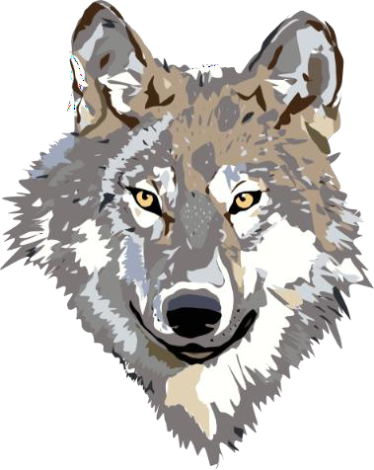Based on the four simulations you ran, describe what happened to your population and answer the experimental question "Does brown fur provide an advantage?" Provide evidence from the simulation to support your conclusions. **(ANSWER IN COMPLETE SENTENCES)**

The brown fur can provide I advantage when in the dessert with wolves. When in the artic it provided no  
advantage but made it worse for the ones with brown fur, by the fact that by the end there were no more   
with brown fur. In the desert without wolve it provided no advantage, but with wolves it provided an   
advantage.

# Experiment B - Does long teeth provide an advantage?

1. Following the guidelines from the Experiment A, determine when long teeth provides an advantage to the bunny population. Based on your tests showing long teeth in a variety of situations, determine when long teeth provide a selective advantage. Provide evidence from the simulation to support your conclusion. **(ANSWER IN COMPLETE SENTENCES)**

**Long teeth provide a advantage when there is tough food, but there isn’t tough food it provides no advantage. When are there is a tough food it gives a advantage since, it’s easier for them to eat the tough food.**

# Experiment Challenge

1. Using the simulation, determine the conditions when a long ears would be an adaptation. If you cannot discover this from the simulation, propose any possible situation where a long ears would provide a selective advantage for bunnies and explain WHY it would be an advantage. **(ANSWER IN COMPLETE SENTENCES)**

**There is no conditions when long ears would be a adaptation. But a condition when it would be adaptation is when they need to hear what happening in the middle of the night.**

# Post-Lab Analysis (ANSWER IN COMPLETE SENTENCES)

1. Define variation. What genetic variations are presented during this simulation?

A variation is a change in DNA, the genetic variations in the simulation are brown fur, sloppy ears, long teeth,

1. Define adaptation. Give examples when an adaptation is beneficial to the bunnies.

A adaptation is a change to help a species survive. A example with the bunnies is when the population grew longer teeth to help eat the tough, or when the bunnies population get browner overall to help blend in with it’s surroundings.

1. What are 3 other (natural) selection factors which effect animal populations in the real world?

Other animals eating other animals, other way is when the ones that live the longest breed more, and it the ones that help it get more food or help it survive.

1. If a bunny population was forced to move to a desert environment, how might natural selection have an effect on the population over time?

The population overall might became browner to blend in with the environment.

12. How has this simulation added to your knowledge of evolution (the study of life’s history and its change over time)?

It added to my knowledge of evolution by showing that more than luck is involved with evolution.